Light  (Natural) | Medium  (Golden Oak) | Dark  (Walnut)
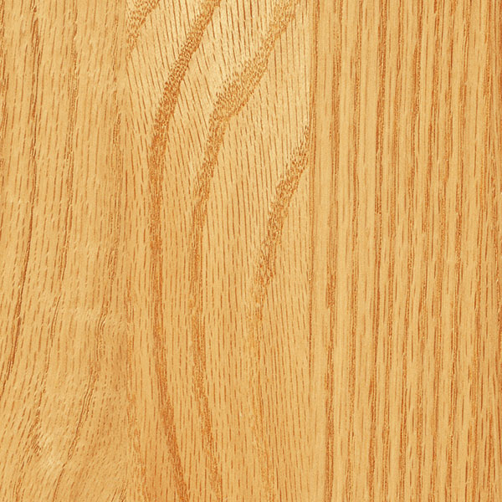 | 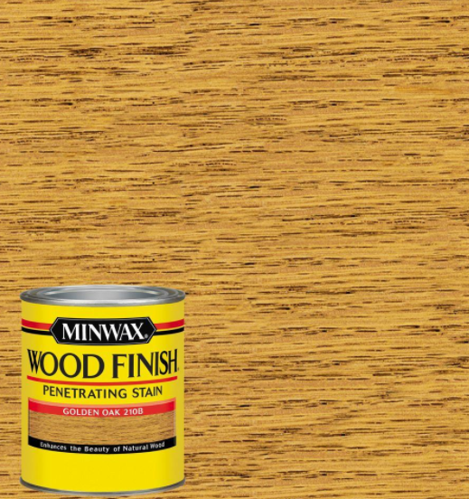 | 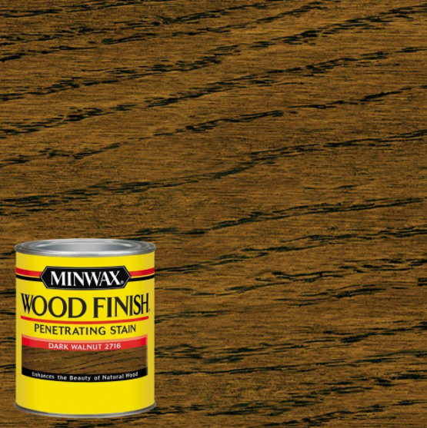

All plaques will be constructed out of ¾” MDF Oak Plywood

